CHEMICAL ENGINEERING TRANSACTIONS  VOL. 91, 2022 | A publication of
The Italian Association
of Chemical Engineering
Online at www.cetjournal.it
Guest Editors: Valerio Cozzani, Bruno Fabiano, Genserik Reniers
Copyright © 2022, AIDIC Servizi S.r.l.
ISBN 978-88-95608-89-1; ISSN 2283-9216

Ship-to-ship LNG bunkering: risk assessment and safety zones
Olga Aneziris^{a,*}, Ioanna A. Koromilaª, Marko Gerbec^{b}, Zoe Nivolianitouª, Ernesto Salzano^{c}
ª National Center for Scientific Research “DEMOKRITOS”, Patriarchou Gr & Neapoleos, Aghia Paraskevi, Greece
^{b} Jozef Stefan Institute, Ljubljana, Slovenia
^{c} Dipartimento di Ingegneria Civile, Chimica, Ambientale e dei Materiali, Università di Bologna, Bologna, Italy
olga@ipta.demokritos.gr
In this paper risk assessment for the ship to ship LNG bunkering is carried out by exploiting the results of the projects “SUstainability PERformance of LNG-based maritime mobility – PLUS” (SUPER-LNG PLUS) financed by Interreg-Adrion and the project “Risk management system for design and operation of installations for LNG refuelling” (TRiTON) financed by the Greek government. Ship to ship bunkering constitutes a simple method when storage tanks cannot be installed in the port areas. In brief, risk assessment is conducted in the following basic steps: a) assessment of plant damage states and their frequency of occurrence, b) assessment of consequences and c) risk integration. First, the Master Logic Diagram (MLD) technique is used to identify the initial events that create a disturbance in the installation and have the potential to lead to an LNG release during a ship to ship bunkering operation. Moreover, safety functions and systems for preventing LNG release, are identified and Event trees are developed to model the accident sequences which lead to damage states. By exploiting available failure rate data, the frequency of each damage state is estimated. In parallel, the consequences of LNG release are estimated based on the heat radiation or overpressure dose an individual receives. Finally, iso-risk contours are calculated by combining the frequencies of the various accidents with the corresponding consequences. A case study for a ship to ship bunkering in a Greek port is presented.
  - Introduction
Over the last few years, there has been an increased demand for liquefied natural gas (LNG) as a marine fuel, owning to the requirements for reducing greenhouse gas emissions. In order to enhance the use of LNG in the marine sector, port installations have been established worldwide providing the key bunkering methods; namely, tank to ship, truck to ship, and ship to ship (Aneziris et al., 2020; Peng et al., 2021). Ship to ship bunkering constitutes a favorable bunkering method for ports serving small to very large capacity ships with a short stay in the port, allowing also simultaneous handling of cargo or passengers. In addition, it is a rational alternative for ports where fixed installations are prohibited or not preferred. Depending upon the port authority, ship to ship bunkering is allowed to take place either at the pier or at anchorage on the open sea. In both cases, a bunker ship is moored alongside the LNG fueled ship. The bunker ship is then connected via flexible hoses or fixed arms.
A bunker ship is an LNG tanker obliged to comply with the International Maritime Organization (IMO) safety requirements, as defined in the international code for the construction and equipment of ships carrying liquefied gases in bulk (IGC Code) (IMO, 2014). A typical capacity of a bunker vessel is 500 to 20,000 m³ (EMSA, 2018). Vessels of such size are conventionally equipped with one or two IMO Type C cargo tanks. Type C tanks are cylindrical or spherical pressurized tanks capable of maintaining LNG at a pressure of 4 to 6 bar when the temperature is -162 °C and can carry 500 to 2,000 m³ LNG (EMSA, 2018).
On the other hand, the LNG fueled ship can be any type of ship, such as passenger ship, bulk carrier, containership, or tanker. This ship shall comply with the provisions of the specially designed international code of safety for ships using gases or other low-flashpoint fuel (IGF code) (IMO, 2015). The LNG fueled ship typically carries one or more LNG fuel tanks reaching a total capacity of 50 to 20,000 m³ depending on its size.
However, LNG in port areas poses risk, since a release and ignition of LNG may affect people in the nearby area. Fu et al. (2016) performed an event tree analysis to investigate the hazards and the potential consequences and conducted a computational fluid dynamics (CFD) simulation to quantify the risk of LNG leakage on a LNG fueled ship. Jeong et al., (2017, 2018, 2020) presented a quantitative method for assessing risk and determined safe exclusion zones for LNG bunkering. Within the published literature, limited analysis for ship to ship bunkering has been performed. Sultana et al., (2019) performed a hazard analysis for ship to ship LNG transfer and Park et al., (2018) assessed factors affecting the safety zone in ship to ship bunkering with CFD simulations. This paper aims at performing a quantitative risk assessment for ship to ship bunkering in Greek ports.
The remaining of the paper is structured as follows. Section 2 describes the basic steps of the risk assessment methodology. Section 3 describes the case study and performs a risk assessment for the ship to ship LNG bunkering. Section 4 presents the limitations and the uncertainties of this assessment and finally, section 5 presents the conclusions of this research.
  - Risk assessment methodology
LNG constitutes a hazardous substance consisting of a mixture of hydrocarbon gases, mainly methane (87–99 mol%), ethane (0.1–5.5 mol%), and propane (0–4 mol%). It is a natural gas that is cooled down to the boiling point at -162 °C to reduce its volume, thus facilitating its transport and storage as well. The accidental release of such a hazardous substance during the ship to ship bunkering may pose significant risks. This can occur in the following way: a) an initiating event occurs that disrupts the normal bunkering operation; b) a series of failures deactivate one or more existing safety systems preventing the release of LNG; c) LNG is released into the environment and dispersed; and d) if vapour is ignited, fire or explosion can cause undesirable consequences.
The probability of an LNG release and the resulting consequences can be quantified by implementing risk assessment models. The key phases of this methodology follow methodological steps presented by (Aneziris et al., 2014). For the sake of brevity, only a short presentation is given in the next sections.
2.1 Phase I: damage states assessment and their frequency of occurrence
The first phase involves the assessment of damage states and their frequency of occurrence. The LNG port facility is thoroughly analyzed to identify potential initial events that may cause LNG accidental release and a Master Logic Diagram (MLD) is developed to determine all the initiators of potential accidents (Papazoglou and Aneziris, 2003). Next, Event Trees are constructed to describe specific accident sequences contributing to detecting the damage states and to prevent the LNG release to the environment. These trees encompass the initial event identification, system failures and success, and human responses as well. In addition, systems failures in terms of basic component failures and human errors, and accident sequences are modelled. Finally, frequencies of accident sequences and plant damage states are calculated with the aid of the Fault Tree and Event Tree analysis.
2.2 Phase II: consequences assessment
The second phase comprises the assessment of the consequences owning to the release of flammable LNG. First, all the types of physical phenomena, such as pool fire, jet fire, flash fire or vapour cloud explosion, that may occur are determined. Assuming the LNG release and the associated physical phenomenon, the heat radiation or the peak overpressure is calculated. The calculation is achieved by using specially designed simulation models, such as those developed by Papazoglou et al., (1996). Heat radiation and overpressure are integrated over time, to assess the dose an individual receives. Appropriate dose/response models are exploited to eventually estimate the probability of fatality of an individual receiving the assessed dose.
2.3 Phase III: risk estimation
The third phase involves the integration of the results of all previous phases. Indeed, the frequencies of the various damage states are combined with the corresponding consequences resulting in the quantification of risk. Individual fatality at a specific location is calculated at the area of interest, which is the port.
  - Case study
3.1 General information
The case study examines the safety during LNG bunkering of a passenger ship, namely the LNG fueled ship, from a bunker ship. The passenger ship is equipped with two Type C storage tanks, each with a 400 m³ capacity of LNG fuel and operates at a pressure of 4 bar. The bunker ship has a pressurised tank with a capacity of 3,000 m³. In order to proceed with the bunkering operations, the passenger ship is moored at the pier, the bunker ship moors alongside, and the tank is loaded through 2 hoses with a diameter 4" at a rate 400 m³/h. For handling emergencies, an automatic Emergency Shut Down system (ESD) exists on both ships, and an emergency release system (ERS) is installed to disconnect the supply side from the receiving vessel.
3.2 Initial events identification
In the first phase of the risk assessment, a Master Logic Diagram (MLD) for the fueled ship is constructed, to determine the initial events that are likely to occur during ship to ship bunkering. In brief, MLDs initiate with the top event “Loss of Containment” which is decomposed into events required to occur for producing this top event. Loss of containment indicates the discontinuity or loss of the pressure boundary between the LNG and the environment, resulting in the release of LNG. Figure 1 presents the MLD developed for the bunker ship. As shown, there are two major categories of events leading to loss of containment: those resulting in a structural failure of the containment and those resulting in the containment bypassing because of an inadvertent opening or an engineered discontinuity in the containment (e.g. valves). Loss of containment due to tank structural failure may be caused by corrosion, overpressure, high temperature, vibration, or external loading. Overpressure may be caused due to internal pressure increase. Internal pressure increase may be caused by inadequate purging, boil-off gas removal malfunction or excess external heat. External loading may be achieved in the next two ways: a) natural phenomena such as high winds, earthquake, and tsunami, or b) extra loads owing to a collision between the two ships, contact with large objects such as cranes, mooring line failure, or poor ballast. On the other hand, loss of containment resulting in a bypass of the containment may be caused either because operations start while the containment is open or because the latter is opened during operations. In addition, in the case of the fueled ship tank, overfilling might further occur. Table 1 presents the list of the initial events, the identified damage states, and the LNG release quantities for the ship to ship bunkering of the case study.
3.3 Major accident scenarios
Once the list of the initial events has been assembled the safety functions and the systems that serve these functions are determined. Safety functions are combinations of engineering systems and human actions aiming at mitigating the possible consequences of the initial events. The safety systems, or similarly frontline systems,

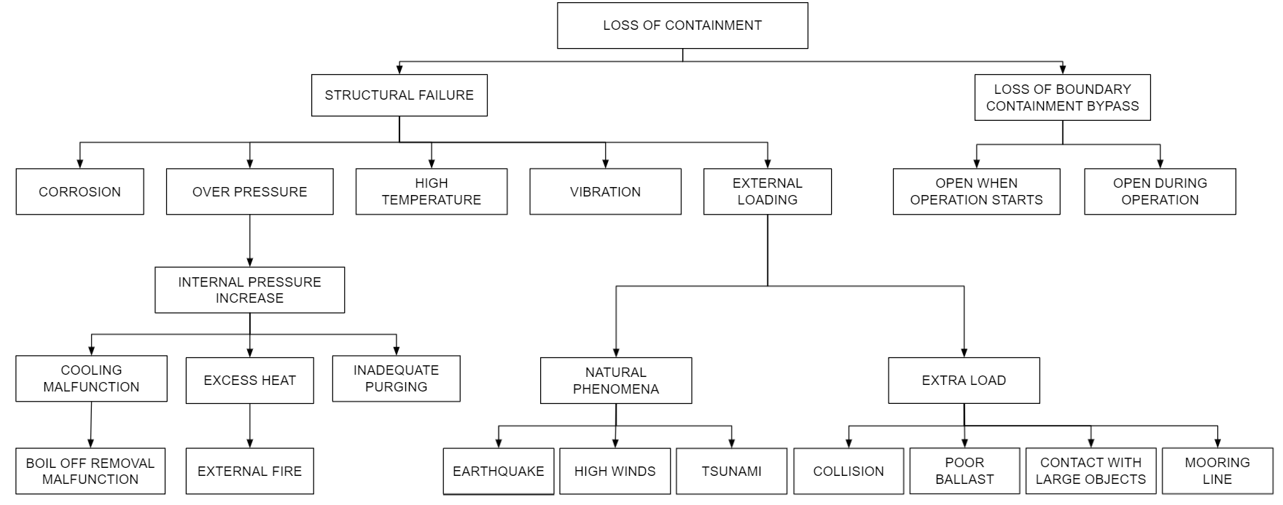
Figure 1: MLD for the bunker ship during ship to ship bunkering operations

are used to construct accident sequences that describe how the occurrence of an initial event and the failure of safety systems result in the final damage state and the release of LNG. Accident sequences are graphically represented through Event Trees and their frequency of occurrence is calculated by using Fault Tree and Event Tree analyses, or previously calculated and reported frequencies. Accident sequences are constructed for the following six identified initial events: boil-off removal malfunction during loading, overfilling of the tank of the fueled ship, inadvertent valve closure during loading, external fire on either ship, extra load in a tank (collision, grounding, poor ballast, mooring line), extra load in hose (earthquake, tsunami, high winds). Table 2 presents the frequencies of all damage states and the associated released quantity.
3.4 Consequences quantification
Once the accident occurs, released LNG will form a pool on the sea surface, close to the release point. If ignition occurs in a relatively short time, the pool will burn until the entire amount of LNG vapour is consumed. If the ignition is late, due to the much higher temperature of the sea environment, LNG will quickly evaporate and form a flammable cloud, which is likely to be carried away by wind and buoyancy. It is worth noting that if the mass flow rate from the leak is relatively high (> 0.2 m³/s), a Rapid Phase Transition (RPT) with measurable overpressure can occur, thus affecting the integrity of the ship vessels (Bubbico and Salzano, 2009).
When the flammable cloud is formed, delayed ignition can occur at the cloud edge or in any other position within the cloud. In this case, a flash fire is characterized by flame propagation from the ignition spot to the pool (the release point). A pool fire and a jet fire (on the ship) are typical phenomena following the flash fire.
In addition, the burning of the flammable cloud can lead to a dramatic vapour cloud explosion (VCE), generating destructive pressure waves which travel in the far-field from the release point. This situation is however unlikely to occur in case of LNG vapour, which consists mainly of methane. Indeed, this gas is characterized by low reactivity at ambient temperature (which further decreases by the low vapour temperature). Furthermore, in case of ship-to-ship bunkering, a relatively un-congested area is predictable. It is also worth noting that partial confinement (e.g. due to the vicinity of the two ships with the tier) can only affect local pressure due to simple thermodynamic consideration, hence without producing pressure waves. Eventually, literature agrees that pool fire and flash fire have by far the largest potential impact distances of all, thus being of prime importance (Pio et. al, 2019 ; Carboni et. al, 2022).

Table 1: List of initial events, identified damage states, and LNG release quantities of the case study
Initial events for both ships | Damage state | Fuelled ship  release quantity
Corrosion | Tank hole | Depending on the hole diameter
High Temperature | Tank rupture | 400 m³
Inadequate purging of loading arm | Hose rupture | Quantity in hose
Overfilling (only for fueled ships) | LNG release | 400 m³
Boil-off removal malfunction | Tank rupture | 400 m³
Excess external heat during unloading | Tank rupture | 400 m³
Vibration | Tank rupture | 400 m³
High wind, earthquake, tsunami | Hose rupture | 400 m³/h
Collision, or contact with large objects | Tank rupture | 400 m³
Poor ballast, or mooring line failure | Hose rupture | 400 m³/h
Valve closure after pumps | Hose failure | 400 m³/h
Valve left open before unloading starts | Hose failure | 400 m³/h
Table 2: Frequency of all damage states and released quantity or rate.
Damage state | Frequency (events/year) | Released quantity or rate
LNG fueled ship’s tank rupture owning to overpressure/ overfilling | 5 10⁻⁷ (RIVM, 2009) | 400 m³
Hose rupture during bunkering | 4 10⁻⁴ (RIVM, 2009) | 400 m³/h

3.5 Risk estimation
The final procedural step of the risk quantification is the integration of the results obtained in the various tasks that combines the frequencies of the various accidents with the corresponding consequences resulting in the quantification of risk, and the overall risk estimation. The measure used for risk quantification is the individual fatality risk at a location. This integration has been achieved with the help of the SOCRATES tool (Papazoglou et. al, 1996). Figure 2 presents a total individual risk for all accidental scenarios. Accidents with the most serious consequences are: a) rupture of LNG fueled ship tank (400 m³) followed by the flash fire of the vapours contained in the tank and b) hose rupture followed by a flash fire. Total individual risk independent of all damage states has been assessed for the LNG ship to ship transfer and is equal to 10⁻⁵, 10⁻⁶/yr at a distance of 90 and 130m respectively, as presented in Figure 2.
  - Limitations & uncertainties
Risk assessment methods and models used are subject to several limitations and related uncertainties. This section will briefly discuss the most important limitations of the risk assessment methods, models and data. The available hazard identification methods are suitable for LNG applications. However, some experimental data, e.g., methane/natural gas mixture flammability limits, in the air depend also on the temperature and therefore their values at the LNG boiling point differ considerably (Pio and Salzano, 2018). This affects the applicable flammability limits. Likelihood assessment of the outcomes of the accidental LNG releases is based on the bunkering equipment failure rate data, probability of failure of the safety devices and probability of the ignition. A recent review of the pertaining uncertainties in the required data (Gerbec and Aneziris, 2020) revealed that the available risk assessment studies used diverse data sources and failure rate data, which span over two to three orders of magnitude. While the differences encountered are not a surprise as such, the large span of the values suggests serious issues in the taxonomy of the original data (e.g., diverse boundaries of the components, safety systems considered or not, consideration or not of external causes, duration of the operations, etc.).
As cited above, literature agrees that the flash fire has the largest potential impact distances, compared to all other hazardous phenomena which may occur after LNG release. Terrain elevations, large obstacles and site-specific wind directions were reported to considerably affect the extent of the flammable cloud (Gerbec et al., 2021). The message here is that advanced CFD dispersion modelling and specific 3D terrain models should be used, while the use of the conventional Gaussian models can lead to extremely conservative results. In Figure 3 the results of an accidental release of 53.2 kg/s LNG for 120 s, at the sea surface, are compared with the two approaches (Gerbec et al., 2021). Map A presents UDM/Gaussian dispersion modelling results for UFL (red colour), LFL (green) and LFL/2 (blue) cloud maximum iso-concentration contours and impact radii (regardless of actual wind direction). Map B presents the CFD dispersion results for LFL iso-concentration cloud maximum shape. It can be concluded that CFD modelling considers wind lee effects between the large ship being bunkered and bunkering ship, thus considerably reducing the flammable cloud size.
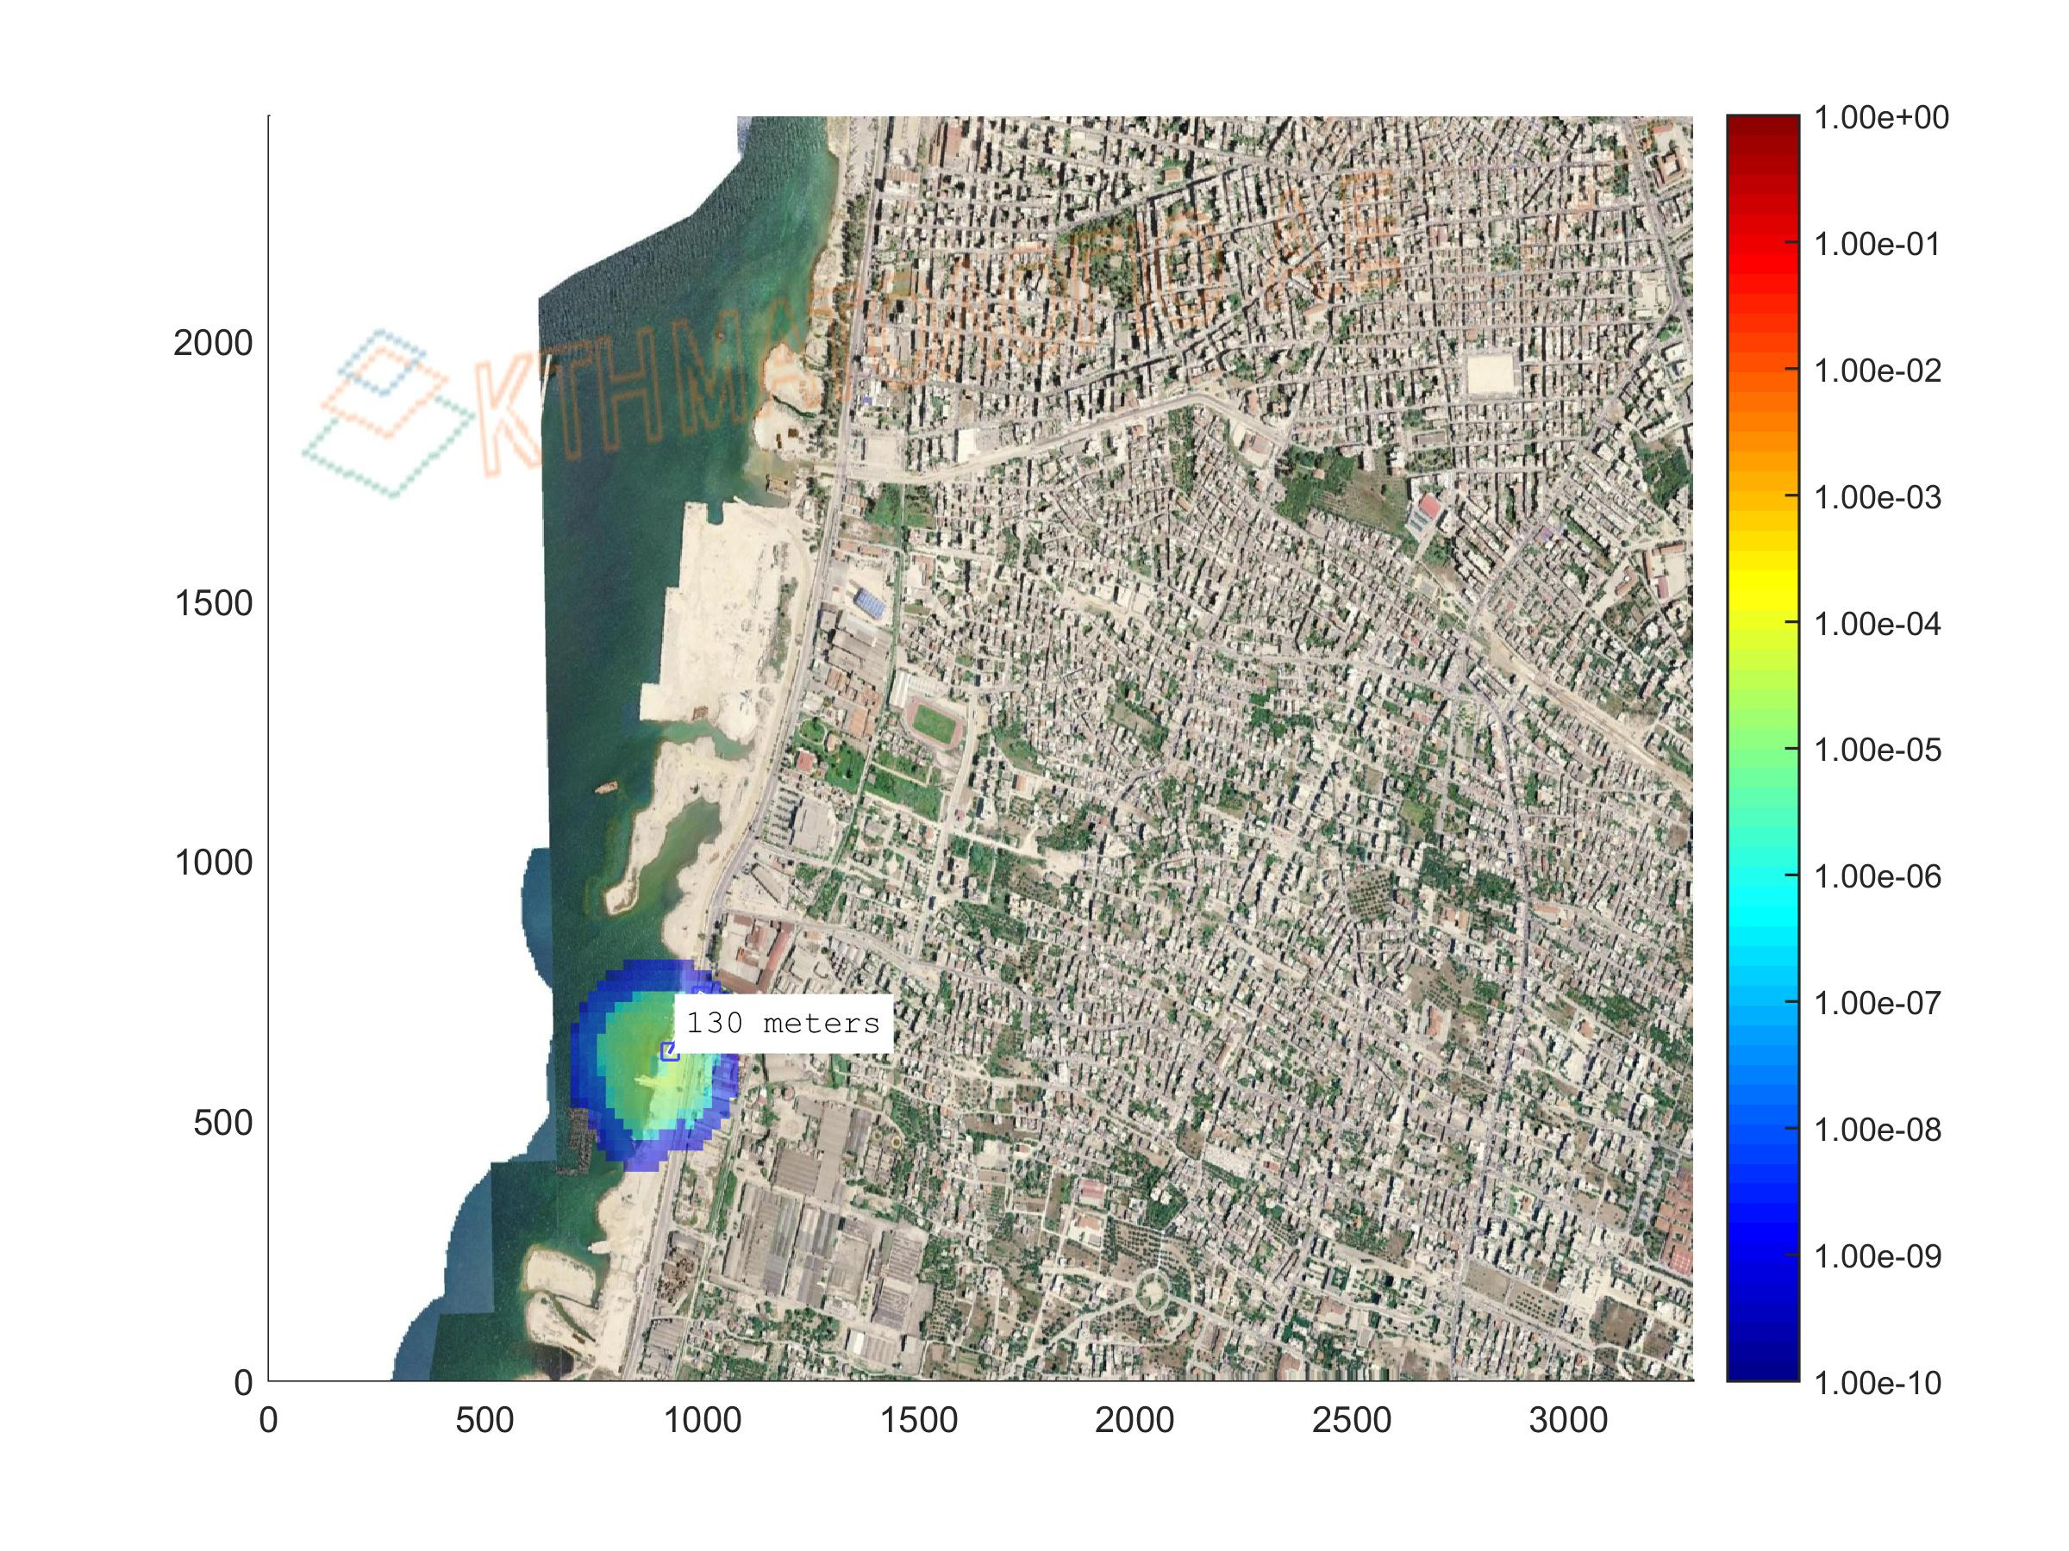
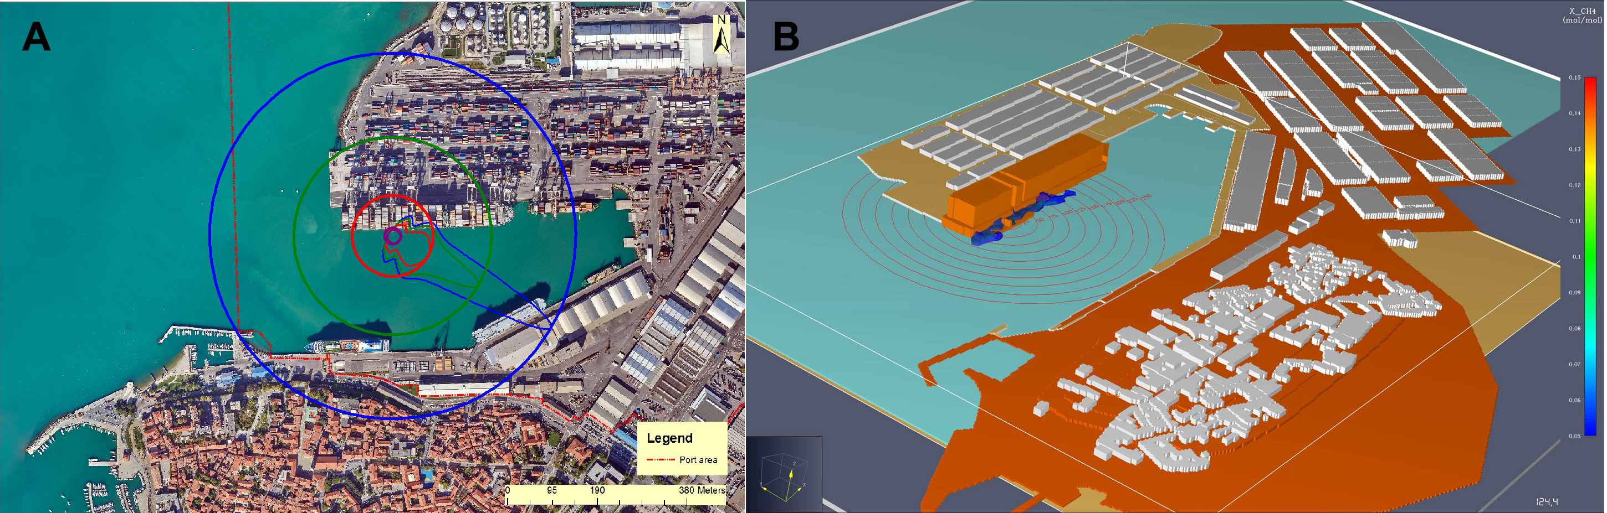
Figure 2: Iso-risk curves for the ship to ship bunkering (Individual risk equal to 10⁻⁶/yr at 130m from the bunkering
Figure 3: Example of iso-concentration contours and radii obtained by Gaussian dispersion modelling (A) and CFD dispersion modelling to LFL (B) for ship to ship bunkering case (Gerbec et al., 2021)

  - Conclusions
In the present paper, the Quantitative Risk Assessment (QRA) methodology and models have been implemented in studying LNG ship to ship bunkering. The probability of an LNG release and the resulting consequences have been quantified. The results obtained include the identification of the initiating events that can cause accidental scenarios together with the determination of accident sequences and damage states. Consequences to nearby population have been assessed by calculating radiation and peak overpressure versus distance. Individual risk contours in a Greek port area have been assessed, owing to LNG bunkering, according to the procedures and assumptions presented in the main body of the paper.

Acknowledgements
This research has been co-financed by the European Union and Greek national funds through the Operational Program Competitiveness, Entrepreneurship, and Innovation, under the call RESEARCH – CREATE – INNOVATE (project code: T1EDK-01727), and the Adriatic-Ionian Programme INTERREG V-B Transnational 2014-2020. Project #1267: SUPER-LNG PLUS “SUstainability PERformance of LNG-based maritime mobility - PLUS”.
References
Aneziris O.N., Koromila I.A., Nivolianitou Z., 2020, A systematic literature review on LNG safety at ports, Safety Science, 124, 104595.
Aneziris, O.N., Papazoglou, I.A., Konstandinidou, Nivolianitou, Ζ., 2014, Integrated risk assessment for LNG terminals, J. Loss Prevention in Process Industries, 28, 23-35.
Bubbico R., Salzano E., 2009. Acoustic analysis of blast waves produced by Rapid Phase Transition of LNG released on water, Safety Science, 47, 515-52.
EMSA, 2018, Guidance on LNG Bunkering to Port Authorities and Administrations, European Maritime Safety Agency, Lisbon, PT.
Carboni M., Pio G., Mocellin P., Vianello C., Maschio G., Salzano E., 2022, On the flash fire of stratified cloud of liquefied natural gas, Journal of Loss Prevention in the Process Industries 75, 104680
Fu S., Yan X., Zhang D., Li C., Zio E., 2016, Framework for the quantitative assessment of the risk of leakage from LNG-fueled vessels by an event tree-CFD, Journal of Loss Prevention in the Process Industries, 43, 42-52.
Gerbec M., Vidmar P., Pio G., Salzano E., 2021, A comparison of dispersion models for the LNG dispersion at port of Koper, Slovenia, Safety Science, 144, 105467.
Gerbec M., Aneziris O., 2020, Uncertainties in Failure Rates of LNG Bunkering Risk Assessment, Proceedings of the 30th European Safety and Reliability Conference and the 15th Probabilistic Safety Assessment and Management Conference, https://www.rpsonline.com.sg/proceedings/esrel2020/pdf/3645.pdf
IMO, 2014, Resolution MSC.370(93) Amendments to the International code for the construction and equipment of ships carrying liquefied gases in bulk (IGC code), International Maritime Organisation, London, UK.
IMO, 2015, Resolution MSC.391(95) Adoption of the International code of safety for ships using gases or other low-flashpoint fuels (IGF code), International Maritime Organisation, London, UK.
Jeong B., Lee B.S., Zhou P., Ha S.-M., 2017, Evaluation of safety exclusion zone for LNG bunkering station on LNG-fueled ships. Journal of Marine Engineering & Technology, 16 (3), 121–144.
Jeong B., Lee B.S., Zhou P., Ha S.-M., 2018, Determination of safety exclusion zone for LNG bunkering at fuel-supplying point. Ocean Engineering, 152, 113–129.
Jeong B., Park S., Ha S.-M. Lee B.S., 2020, Safety evaluation on LNG bunkering: To enhance practical establishment of safety zone, Ocean Engineering, 216, 107804.
Papazoglou I.A., Aneziris O., Bonanos, G., Christou, M., 1996, SOCRATES: a computerized toolkit for quantification of the risk from accidental releases of toxic and/or flammable substances, International Journal of Environment and Pollution, 6 (4-6), 500-533.
Papazoglou I.A., and Aneziris O.N., 2003, Master Logic Diagram: Method for hazard and Initiating event identification in process plants, Journal of hazardous materials, A97, 11-30.
Park S., Jeong B., Yoon J.Y., Paik J.K., 2018, A study on factors affecting the safety zone in ship-to-ship LNG bunkering, Ships Offshore Struct., 13, 312-321
Peng Y., Zhao X., Song X., 2021, A systematic literature review on port LNG bunkering station, Transportation Research Part D: Transport and Environment, 91,102704
Pio G., Salzano E., 2018, Flammability parameters of liquefied natural gas, Journal of Loss Prevention in the Process Industries, 56, 424-429
Pio G., Carboni M., IannacconeT., Cozzani V., Salzano E., 2019, Numerical simulation of small-scale pool fires of LNG. Journal of Loss Prevention in the Process Industries 61, 82-88.
Sultana S., Okoh P., Haugen S., Vinnem J.E., 2019, Hazard analysis: Application of STPA to ship-to-ship transfer of LNG, Journal of Loss Prevention in the Process Industries, 60, 241-252

